IELTS Listening Map Exercises
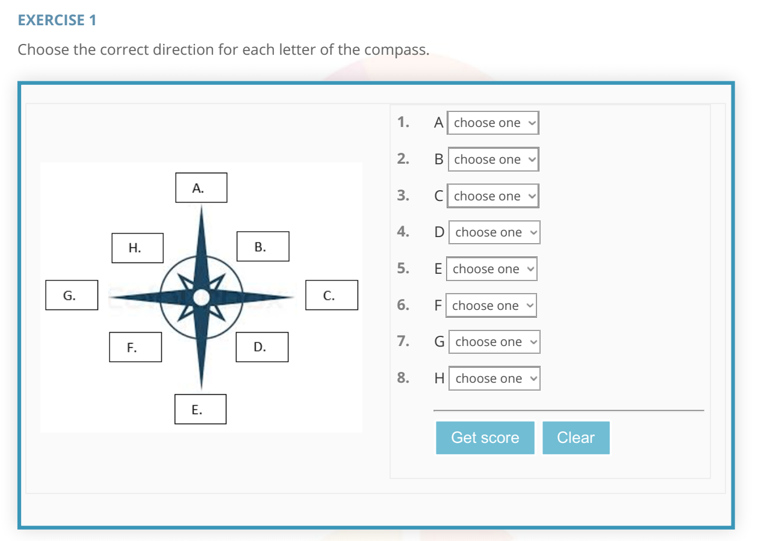
Answers are on the NEXT PAGE

Answers Exercise 1
1. North
2. Northeast
3. East
4. Southeast
5. South
6. Southwest
7. West
8. Northwest

Exercise 2 (4 Sets of Questions for This One Map)
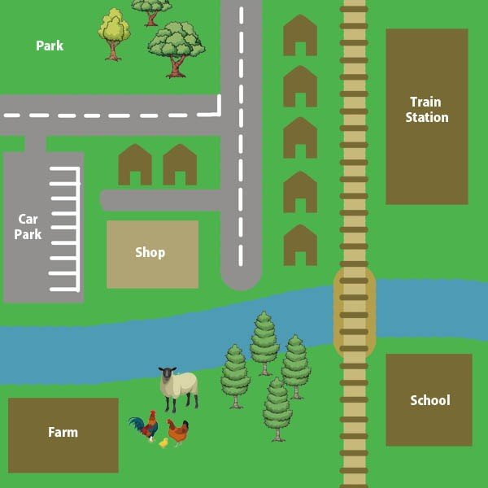

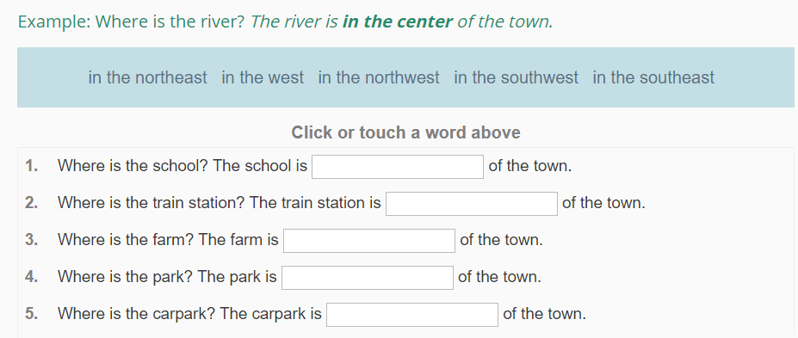

What is the relationship between the two places?
Example: The school is to the east of the farm.
1. | The shop  the park.
2. | The train station the shop.
3. | The train station the river.
4. | The farm the park.
5. | The park the school.

Example: Where is the main road? The main road runs from the river to the north of the town.
1. | Where is the river? The river the east of the town.
2. | Where is the train line? The train line north the town.

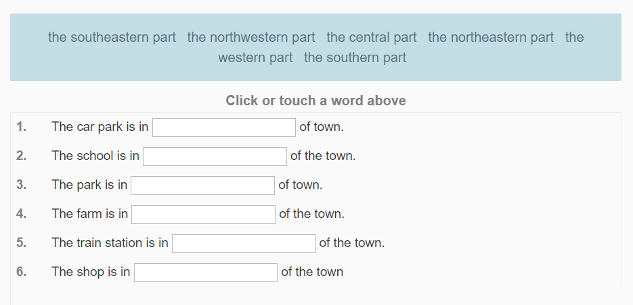
Note: The Answers are on the next page!

Exercise 2 Answers
